***ONLINE APPENDIX to*** Somashekhar, Mahesh. 2018. “Has the Suburbanization of Ethnic Economies Created New Opportunities for Income Attainment?” Social Science Quarterly 99(1):62-79.

***Appendix A1. Operationalizing Suburban Areas***

The distinction between urban and suburban areas is traditionally made by treating central cities in metropolitan statistical areas (MSAs) as urban. Suburbs are the portion of each MSA that excludes central cities (Alba et al., 1999). The smallest geographical unit available from the Census Bureau is the Public Use Microdata Area (PUMA), an arbitrarily bounded geographical unit that ranges from 100,000 to 200,000 residents. The geographical building block of my analysis is the Place of Work PUMA (PWPUMA), not the PUMA. PWPUMAs are frequently equivalent to PUMAs, but the Census Bureau sometimes aggregates PUMAs within PWPUMAs in order to maintain the confidentiality of respondents.

PWPUMAs, like PUMAs, occasionally cross the city-suburb divide. Throwing out PWPUMAs sharing urban and suburban territory would result in a steep loss of ethnic economies available for analysis. Social scientists sometimes relax PUMA boundary conditions such that if some of a metropolitan PUMA’s residents live in a central city, then the PUMA is considered urban. The inverse yields a suburban PUMA. Since the population minimum in published research using this approach ranges from 50 percent (Holzer and Stoll, 2007:2-3) to 95 percent (Alba et al., 1999:ftnote 3), I use a rough midpoint of 75 percent. If 75 percent or more of a PWPUMA’s residents live in a central city, then the PWPUMA is considered urban. If 75 percent or more of a PWPUMA’s residents live outside a central city but within the MSA, then the PWPUMA is considered suburban.

It should be noted that, although the PWPUMA is the geographical building block of my analysis, I aggregate PWPUMAs into urban and suburban portions of each MSA. By aggregating the data into larger spatial units, I minimize any sampling bias that may occur in the data. This is particularly important for 2010 ACS data, which come from a smaller sample than the 1990 and 2000 Decennial Censuses (Census Bureau, 2011).

***Appendix A2. Operationalizing Ethnic Economies***

The odds ratio mentioned in the text is given by:

$${Odds Ratio}_{ijk}=\frac{\left(\frac{W_{ijk}}{W_{i\left(\sim j\right)k}}\right)}{\left(\frac{G_{ijk}}{G_{i(\sim j)k}}\right)}$$

where, in each metro area *k*, the numerator represents the odds that workers *W* from ethnic group *i* work in industry *j*, and the denominator represents the odds that workers from all other groups *G* work in the same industry *j*. *~j* denotes all industries except for industry *j*. As mentioned in the body of the paper, the odds ratio is calculated separately for self-employed and wage workers. If the odds ratio is greater than 1.5 for both self-employed and wage workers, then all workers *Wijk* are treated as part of the ethnic economy. For example, if *Wijk* is the number of Korean workers in the Chicago MSA’s restaurant industry, then *Wi(~j)k* refers to all Korean workers in the Chicago MSA who do not work in the restaurant industry. If *Gijk* is the number of non-Korean workers in the Chicago MSA’s restaurant industry, then *Gi(~j)k* refers to all non-Korean workers in the Chicago MSA who do not work in the restaurant industry. If the odds ratio is greater than 1.5 for both self-employed and wage workers, then all Korean workers in the Chicago MSA’s restaurant industry are treated as part of Chicago’s Korean ethnic economy.

In addition to the odds ratio specification, I limit industries in the analysis to those that are non-professional, non-agricultural, non-mining, non-military, and non-governmental. Governmental and military workers cannot be self-employed, farmers and miners are rarely found in the city or suburbs, and professional industry workers can rely on their high human capital rather than ethnic resources to start a business. Although I exclude professional industries from the analysis, I still allow for workers in professional occupations in non-professional industries to be included in the analysis. The final criterion I impose is a requirement such that, in order to be part of the ethnic economy in an MSA, the ethnic self-employed in a particular industry must make up at least one percent of all the self-employed in that industry in the MSA. This ensures that very small groups are not mistaken to have a notable ethnic economy in an MSA. Very few industries were affected by this cutoff, yet I use it for added rigor.

***Appendix A3. Selected Ethnic Economy Workforce Characteristics***



1. For Whites, these values were not calculated for ethnic economies but for the industries in which they were overrepresented.

2. All variables in these columns were calculated only for those metro areas in which the particular group had an ethnic economy.

***Appendix A4. Median Number of Ethnic Economy Workers for Selected Groups, by Year***

The figure below reveals the extent to which ethnic economy suburbanization followed general work decentralization, the association posited by Hypothesis 1c. To simplify the presentation, I limit the figure to groups emblematic of larger trends. The average number of Whites working in a central city dropped by almost one-fourth from 1990 to 2010, while the number in the suburbs doubled. Among ethnic minority groups, only Korean ethnic economies followed a similar trend. Dominican ethnic economies hardly suburbanized throughout the same time period. Chinese ethnic economies, in a different manner, grew substantially in the suburbs but also grew in the city. Finally, Mexican ethnic economies grew roughly equivalently in both the city and suburbs. In sum, I reject Hypothesis 1c.

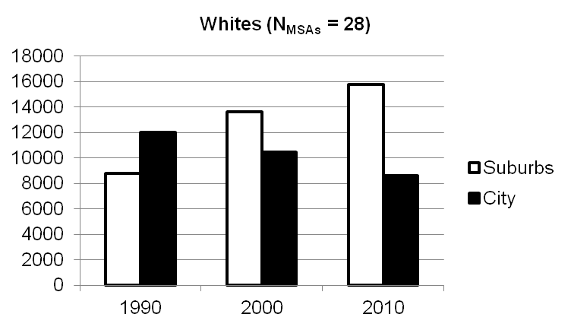

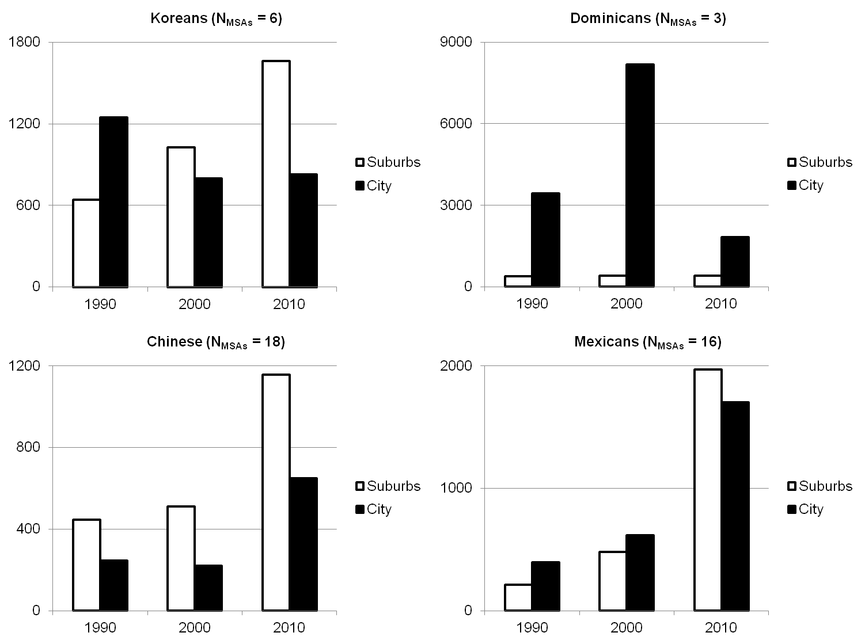

Rather than highlight workers in White ethnic economies, the first bar chart refers to those industries in which native-born, non-Hispanic Whites workers were overrepresented locally as self-employed and wage workers.

***Appendix A5. Univariate Statistics and Correlation Matrices for the Dependent and Independent Variables Used to Test Hypothesis 1***



‘EP’ refers to the local ethnic population of the MSA in which the ethnic economy occurred.

1. See Lieberson (1976).

2. Recent immigrants are those who moved to the U.S. within the five years prior to when data were collected.

3. Linguistic isolation includes those members of the local ethnic population who spoke little to no English.

*Ethnic Economies, 1990*



*Non-Hispanic Whites, 1990*



‘EP’ refers to the local ethnic population of the MSA in which the ethnic economy occurred.

1. See Lieberson (1976).

2. Recent immigrants are those who moved to the U.S. within the five years prior to when data were collected.

3. Linguistic isolation includes those members of the local ethnic population who spoke little to no English.

*Ethnic Economies, 2000*



*Non-Hispanic Whites, 2000*



‘EP’ refers to the local ethnic population of the MSA in which the ethnic economy occurred.

1. See Lieberson (1976).

2. Recent immigrants are those who moved to the U.S. within the five years prior to when data were collected.

3. Linguistic isolation includes those members of the local ethnic population who spoke little to no English.

*Ethnic Economies, 2010*



*Non-Hispanic Whites, 2010*



‘EP’ refers to the local ethnic population of the MSA in which the ethnic economy occurred.

1. See Lieberson (1976).

2. Recent immigrants are those who moved to the U.S. within the five years prior to when data were collected.

3. Linguistic isolation includes those members of the local ethnic population who spoke little to no English.

***Appendix A6. Unweighted OLS Regressions of Logged Annual Income on Key Correlates***

*1990*



*p<0.05

‘EE’ stands for Ethnic Economy. ‘SE’ stands for Self-Employed.

*2000*



*p<0.05

‘EE’ stands for Ethnic Economy. ‘SE’ stands for Self-Employed.

*2010*



*p<0.05

‘EE’ stands for Ethnic Economy. ‘SE’ stands for Self-Employed.